OUTPUT
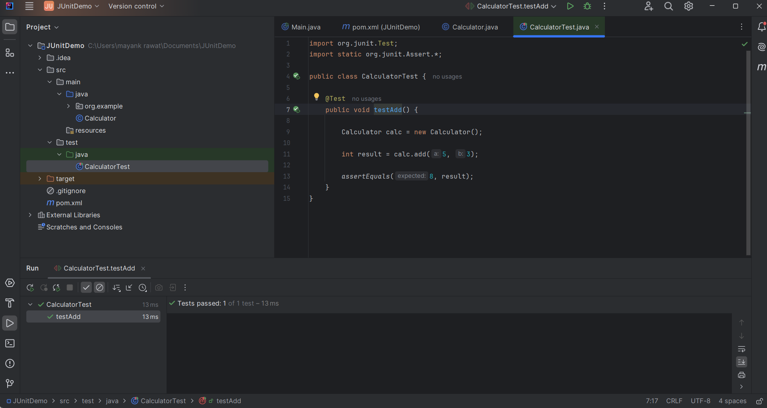

CODE

Calculator
This section provides the core logic for the Calculator class, including a basic addition method.

public class Calculator {
public int add(int a, int b) {
return a + b;
}
}


Calculator test
The following unit test verifies the functionality of the Calculator class using the JUnit framework.

import org.junit.Test;
import static org.junit.Assert.*;

public class CalculatorTest {
@Test
public void testAdd() {
Calculator calc = new Calculator();
int result = calc.add(5, 3);
assertEquals(8, result);
}
}

Pom.xml
This XML configuration file (pom.xml) defines the Maven project settings and its dependencies, such as JUnit.

<?xml version="1.0" encoding="UTF-8"?>
<project xmlns="http://maven.apache.org/POM/4.0.0"
xmlns:xsi="http://www.w3.org/2001/XMLSchema-instance"
xsi:schemaLocation="http://maven.apache.org/POM/4.0.0 http://maven.apache.org/xsd/maven-4.0.0.xsd">
<modelVersion>4.0.0</modelVersion>
<groupId>org.example</groupId>
<artifactId>JUnitDemo</artifactId>
<version>1.0-SNAPSHOT</version>
<dependencies>
<dependency>
<groupId>junit</groupId>
<artifactId>junit</artifactId>
<version>4.13.2</version>
<scope>test</scope>
</dependency>
</dependencies>
<properties>
<maven.compiler.source>21</maven.compiler.source>
<maven.compiler.target>21</maven.compiler.target>
<project.build.sourceEncoding>UTF-8</project.build.sourceEncoding>
</properties>
</project>


